What is a Loop?
A loop is used to repeat a block of code multiple times until a certain condition becomes false.
For example:
👉 If you want to print numbers from 1 to 10 — instead of writing 10 print statements, you can use a loop!

🔹 Types of Loops in Java
There are 3 main types of loops in Java:
Type of Loop | When to Use | Syntax Style
for loop | When you know how many times you want to repeat the code | Compact, all parts (start, condition, update) are in one line
while loop | When you don’t know how many times but want to continue until a condition is true | Condition is checked before each loop
do-while loop | Similar to while, but runs at least once, even if the condition is false | Condition is checked after the loop
Syntax –
Do-while loop :
do
{
// CODE
}while( condition );

While loop :
For loop :
for( initialization; condition; incr/decr)
{
// CODE
}

while( condition )
{
// CODE
}

1️⃣ Print numbers from 1 to 10
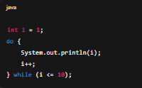
Using do-while loop:

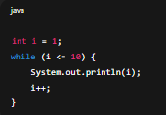
Using while loop:

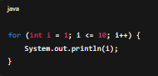
Using for loop:

Print numbers from 10 to 1
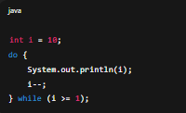
Using do-while loop:

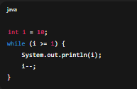
Using while loop:

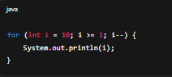
Using for loop:

Print table of 5
Using do-while loop:
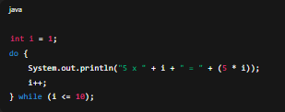
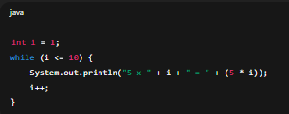
Using while loop:

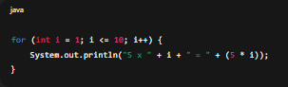
Using for loop:

Few more examples :
- Print even numbers from 1 to 100
- Print odd numbers from 1 to 100
- Print number from 1 to 50 but will incremented value by 3 – i.e 1 4 7 10 13 16 …..

